ABOUT US

A MODERN FAMILY BUSINESS WITH
3 GENERATIONS OF EXPERTISE IN
SERVICE, SUPPLY AND SOURCING
FOR INDUSTRY

We are a modern, forward looking family business with 3 generations of
Expertise in service, supply and sourcing for the industry. We help companies to
Manage, buy and source industrial supplies and tools. We are passionate
bout what we do and the impact that our work has on our team, customers,
suppliers and the world around us. We work hard to develop and maintain
longstanding relationships based on growth, thrust, honesty and sustainability.

We’re a British company based in Burton Upon Trent. We have Offices, Warehouse and Trade Counter serving industrial companies with Staffordshire, Derbyshire and Beyond.

We are a family business guided by strong ethical principles and shared values. We recruit our team, customers and suppliers to the values expressed in our 4 agreements.

We support our customers to learn to buy effectively through training, supply reviews and buying guides.

Our team are knowledgeable and experienced. We are also committed to ongoing training so that we can help you to get what you need.

We are an award-winning company named by the THS National Tool Buying Group as member of the year.

We believe that buying industrial tools and supplies should be easy and enjoyable. If it isn’t easy for you – Let us source, it for you!

3 GENERATIONS – THE STORY SO FAR
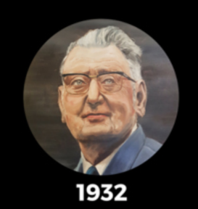


1932 – SERVICE TO THE COMMUNITY
Co-Founder William Clark establishes the company with specialist saw and tool regrinding services to local businesses, professionals and trades people.
1974 -SUPPLIER OF TOOLS TO INDUSTRY
Managing Director Brian Clark modernises the company, widens the customer base and focusses on the supply of Hand Tools, Power Tools and Industrial products to the industry.
2000 - SOURCING & SUPPLY SPECIALISTS
Managing Director Simon Douglas-Clark & Creative Director Monica Douglas-Clark expand Jones and Clark by moving to a larger premises, updating the company’s technology and adding Sourcing Services to our already impressive catalogue of services and supply.
2019 - STOCK MANAGEMENT EXPERTS
Current Director Simon Douglas-Clark leads the next growth phase of Jones and Clark as experts in Stock Management Systems for industry.

